**QUICK HEALTH CERTIFIED AUDIT REPORT**

**HOME PAGE**

**Performance:** Performance on mobile is 61 should be above 90+

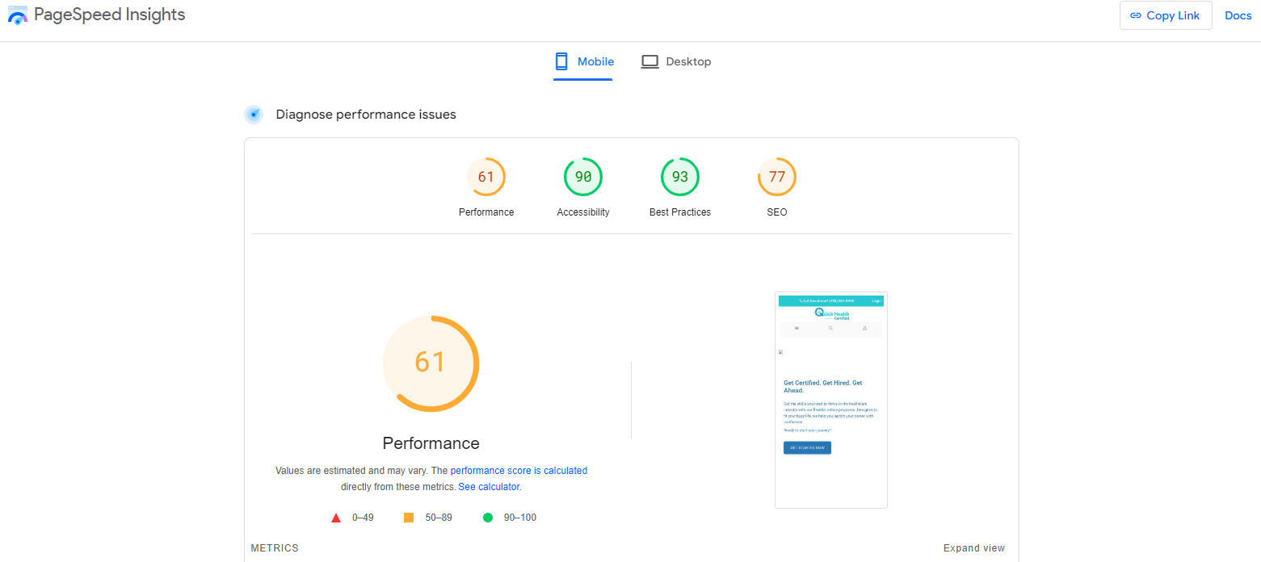

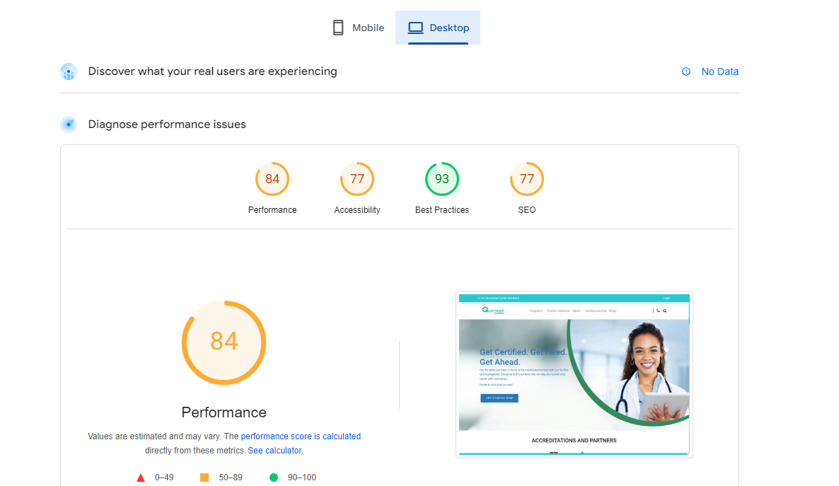**Performance:** Performance on Desktop is 84 should be above 90+

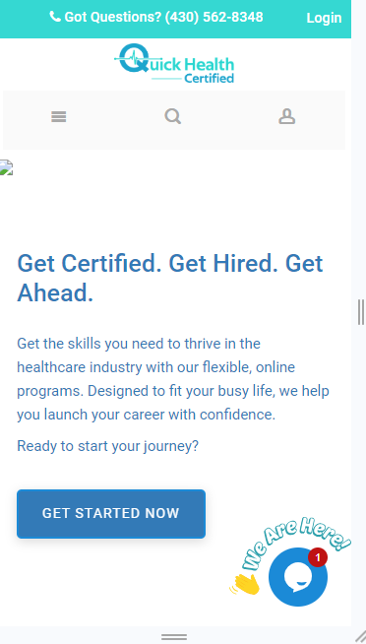**P:** The banner image is not rendering on mobile

**Mobile Responsive Issues:** The heading and text is not properly well aligned



**Mobile Responsive Issues:** The sections **Quick health certified compares** pricing is not properly showing on mobile

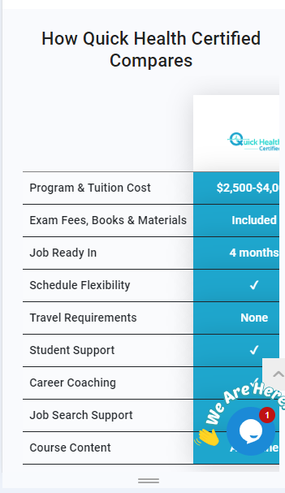

**Mobile Responsive Issues**: The texts on the footer section are not properly well align should be justified

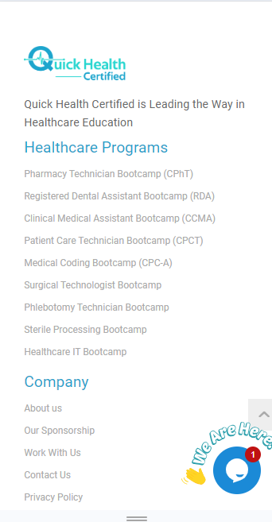

**Button Functionality Issue:** The button **Get started Now** is not redirecting

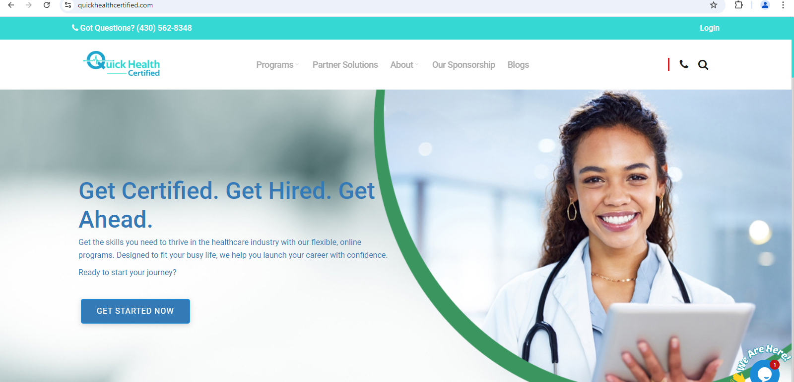

**Button Functionality Issue:** The button **Get free Career Assessment** is not redirecting



**Button Functionality Issue:** Search button in the navigation bar is not working

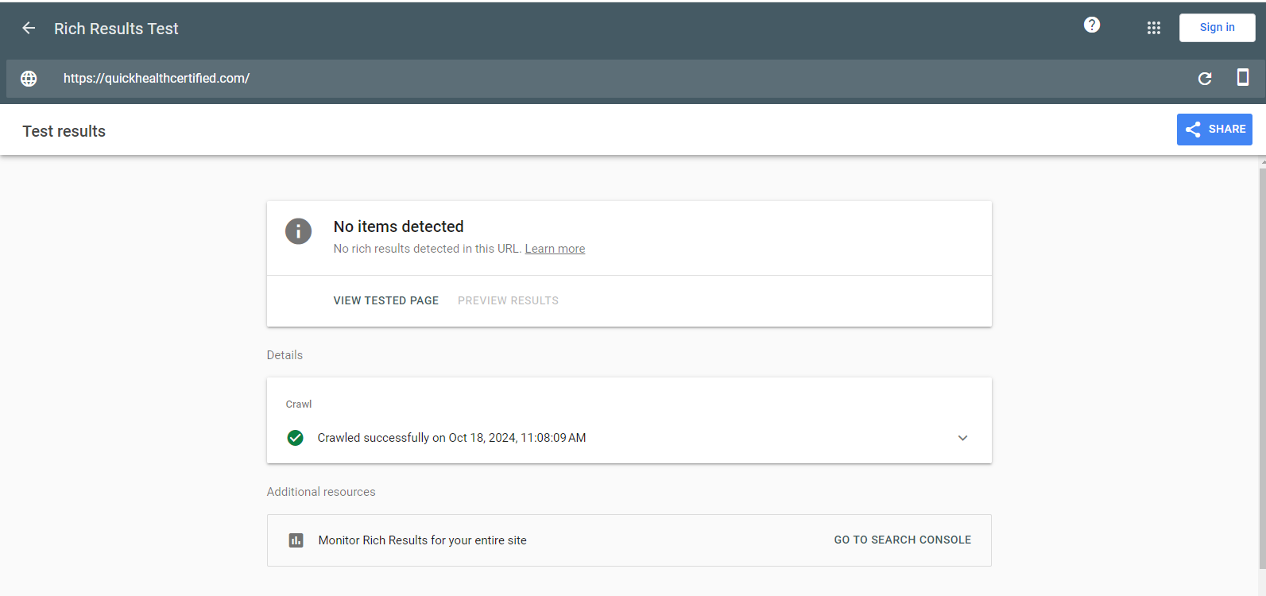**Schemas Markups:** No Schema data has been found in the home page

**PARTNER SOLUTION PAGE**

**Performance Issues:** Performance on mobile is 46 should be above 90+

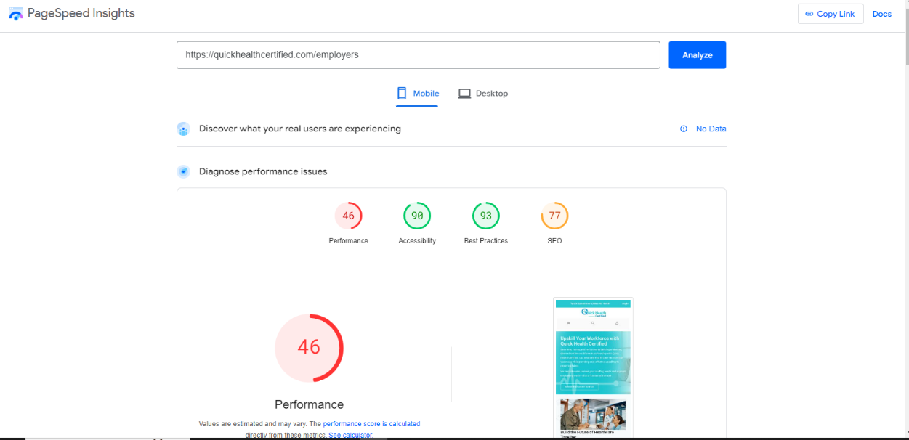

**Performance Issues:** Performance on mobile is 46 should be above 90+

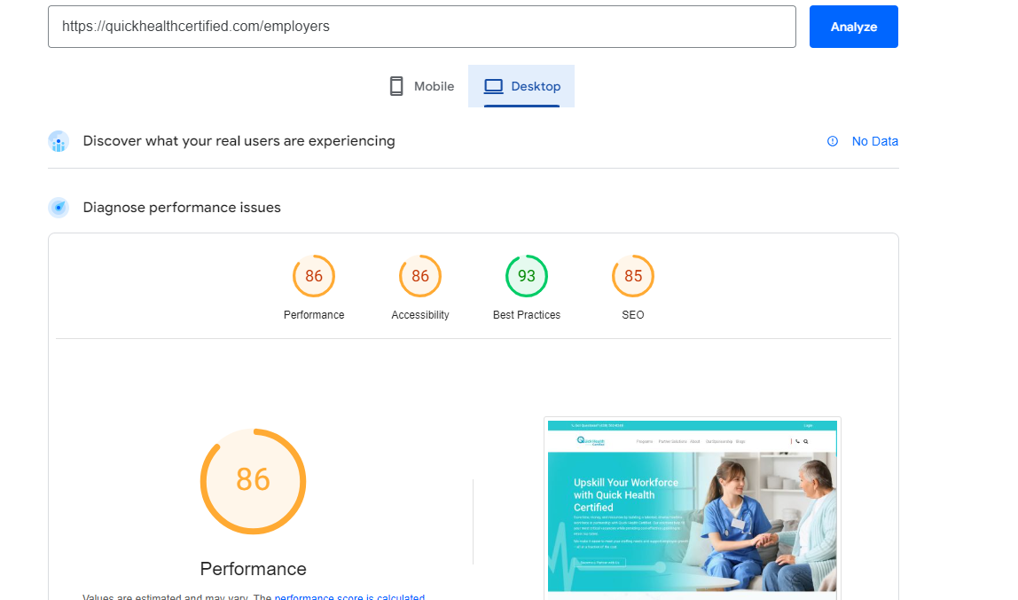

**Mobile Responsive Issues:** The heading and text are not properly well aligned



**Mobile Responsive Issues:** The heading and text are not properly well aligned

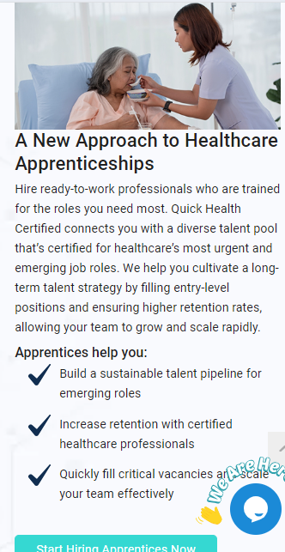

**Button Functionality Issue:** Button **Become a partner with** us is not working and redirecting

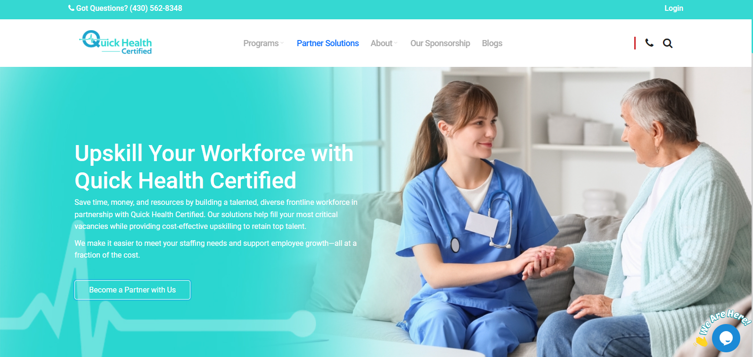

**Button Functionality Issue:** Button **Build your workforce today** is not working and redirecting

**Button Functionality Issue:** Button **start hiring apprentices** is not working and redirecting

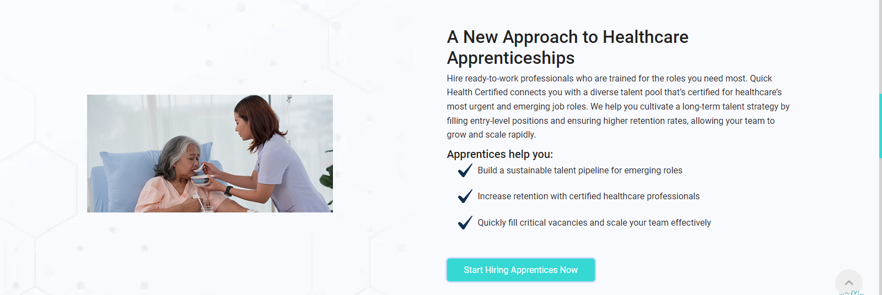

**Title length:** The title length should be in 60 characters



**Schema Markup:** No schema data has been found in Partner Solution Page

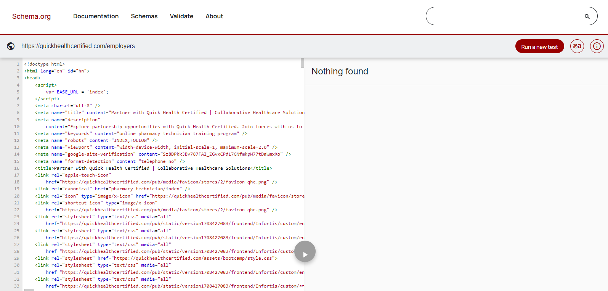

**About Us Page**

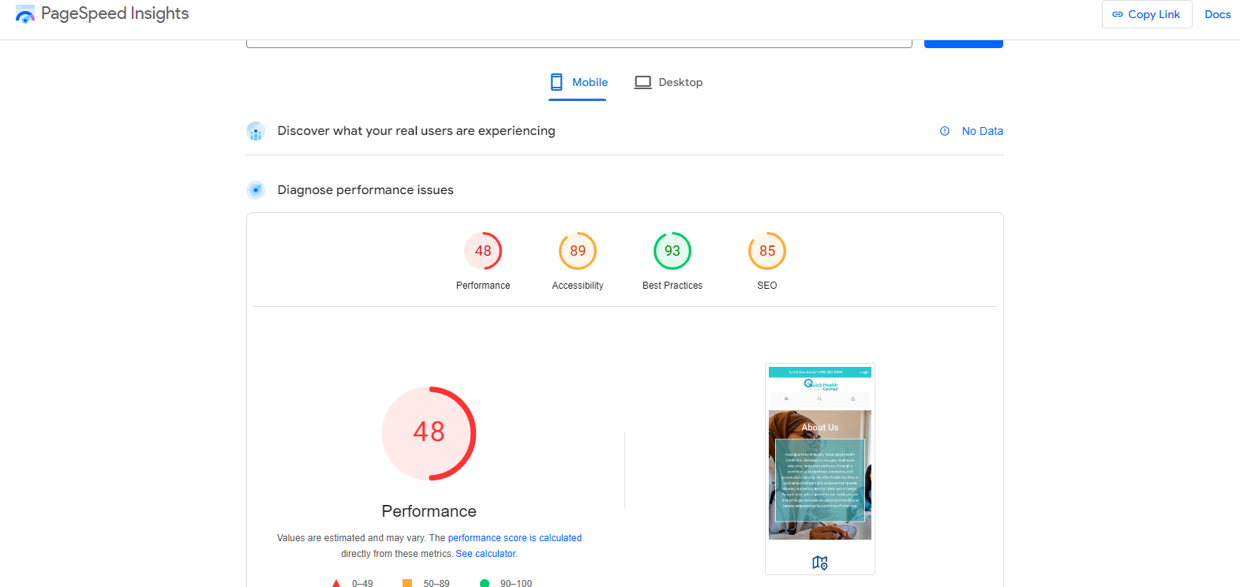**Performance Issues:** Performance on mobile is 48 should be above 90+

**Performance Issues:** Performance on desktop is 76 should be above 90+

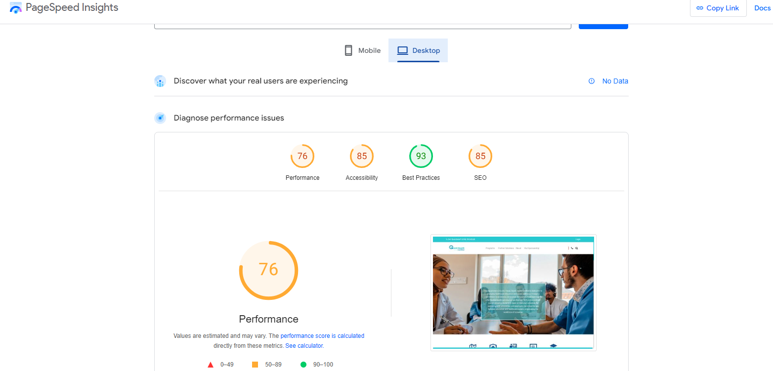

**Mobile Responsive Issues:** The button **view more bootcamps** is not well aligned on mobile and desktop also

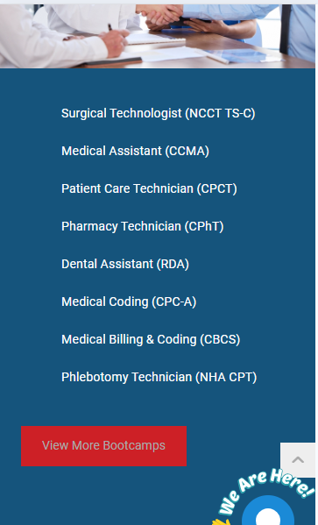

**Mobile Responsive Issues:** The heading and text are not properly well aligned

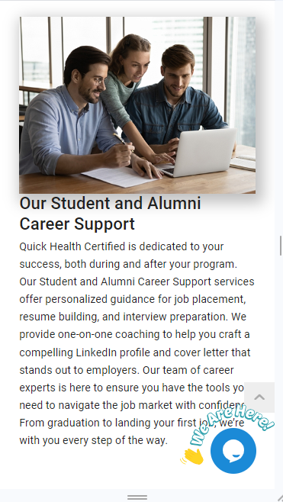

**Spacing Issues:** There should be less gap in Accreditation and Partners

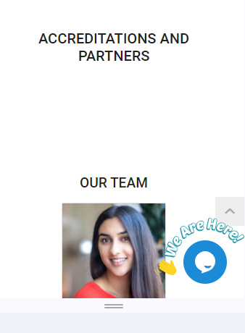

**Content Issue:** The content in the vision and mission should written in more concisely manner

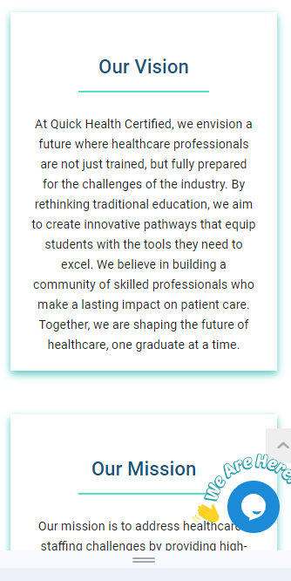

**Enhance the 'Our Team' Section**: The 'Our Team' section should be improved to enhance the user experience. Here are some templates for reference: <https://dribbble.com/tags/our-team>

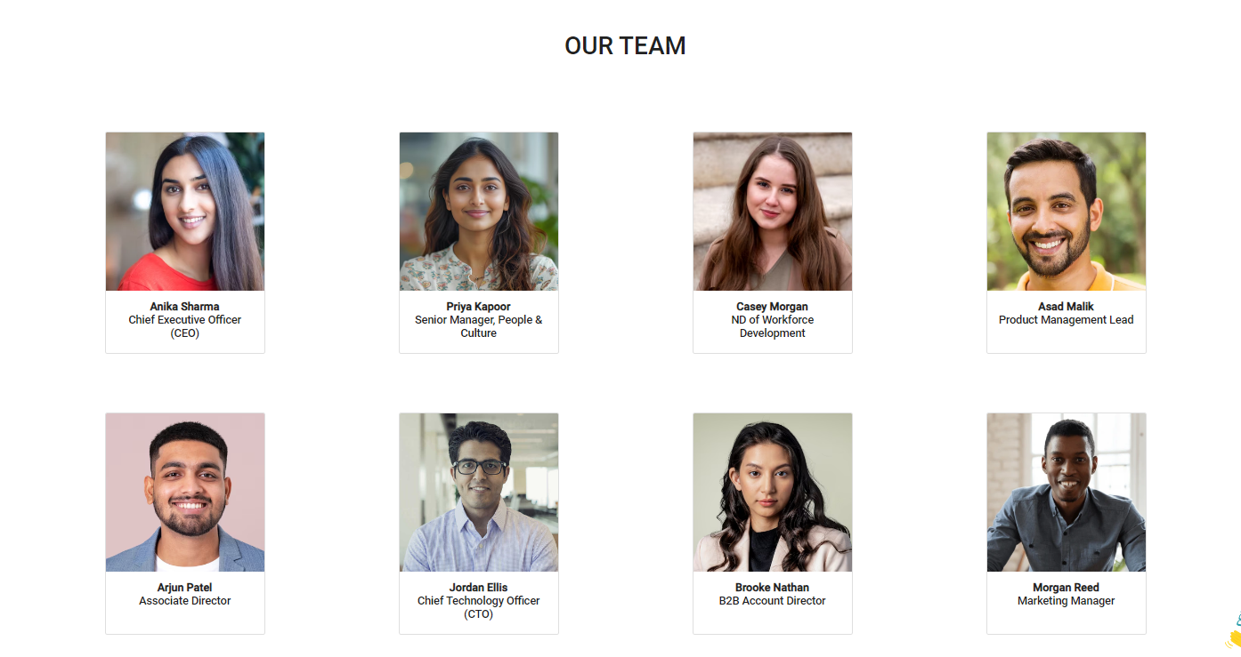

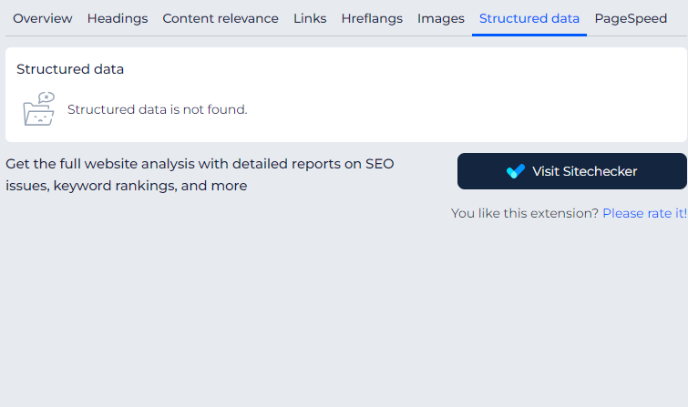**Schema Markup:** No structured data has been Found

**Image SEO:** Many Images in the About us Page does not have an Alt Text

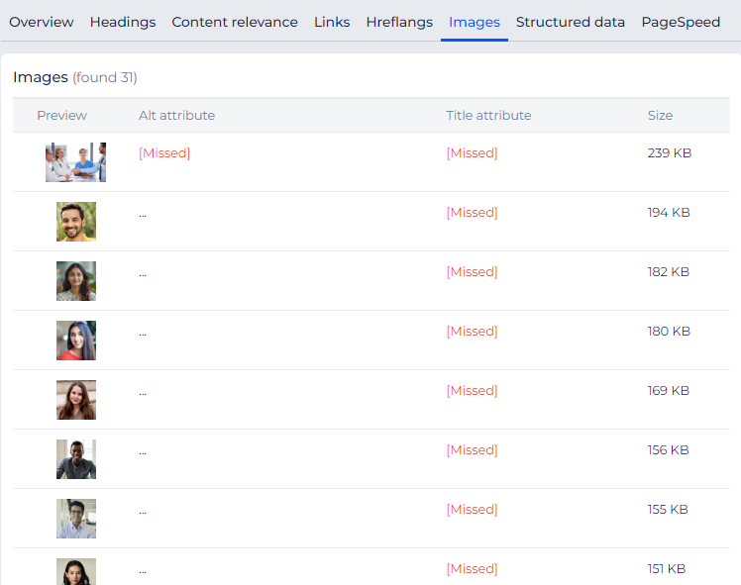

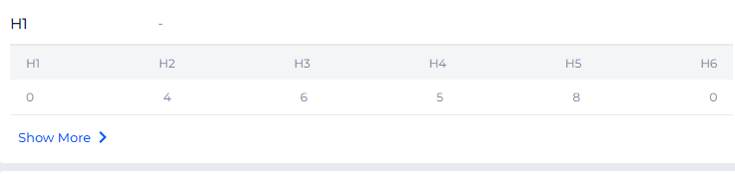

**Header Tag:** No h1 tag has been found in About us Page

**Section Sizes:** The sections **'Our Vision'** and **'Our Mission'** are not the same size

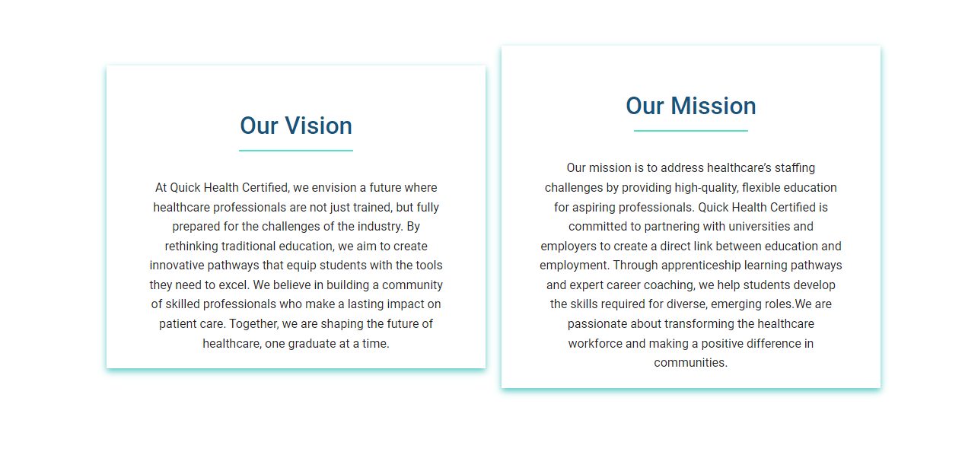

**STUDENT SUPPORT PAGE**

**Performance:** Performance on mobile is 27 should be above 90+

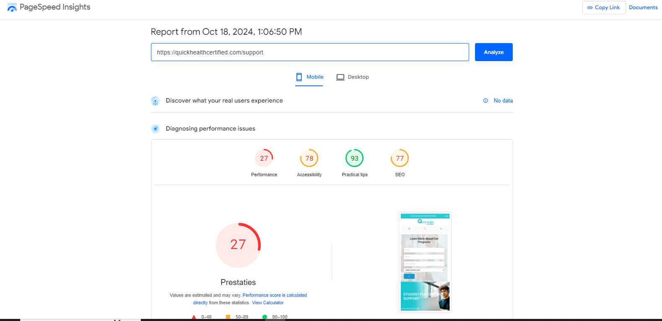

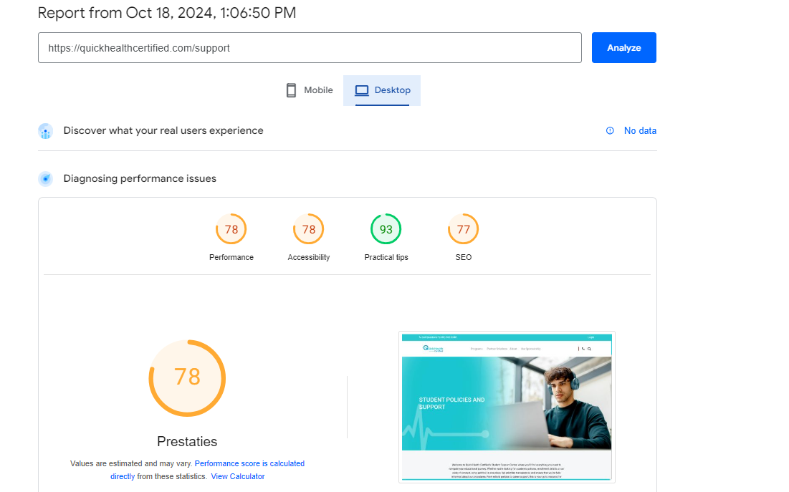

**Performance:** Performance on Desktop is 78 should be above 90+

**Mobile Responsive Issues:** The Text is not properly well aligned

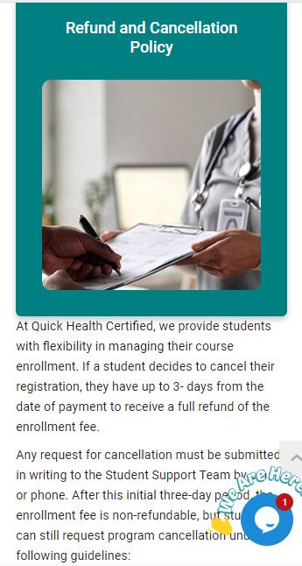

**Mobile Responsive Issues:** The Text is not properly well aligned

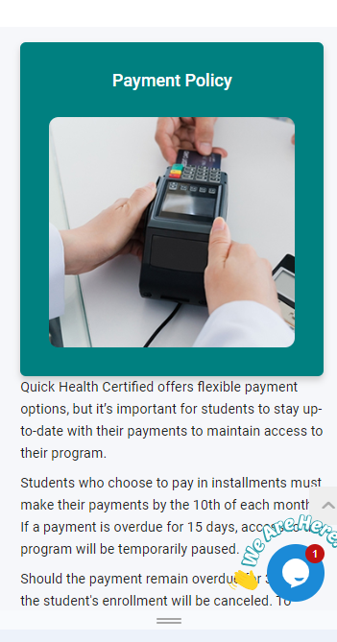

**Mobile Responsive Issue:** Explore QHC Programs is not Responsive

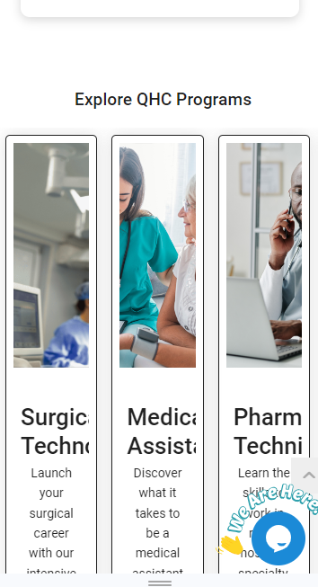

**Schema Markup:** Schema data is not found

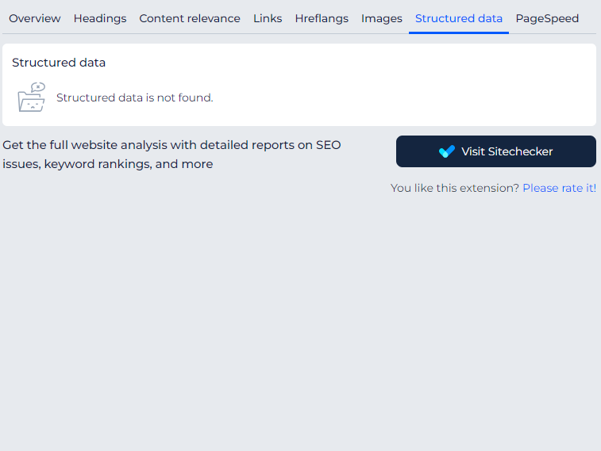

**PROGRAMS PAGES**

The content on the program pages is incorrect; the program pages should be well optimized.

**Alignment Issues:** Bullets points is not properly well aligned

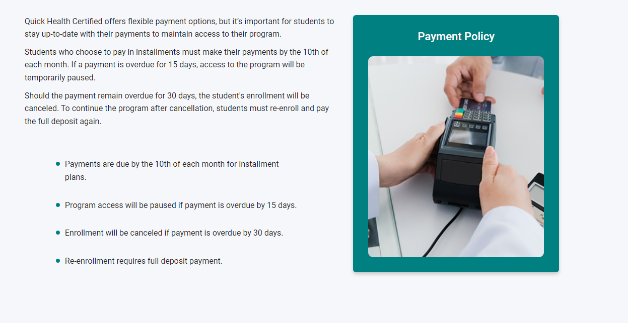

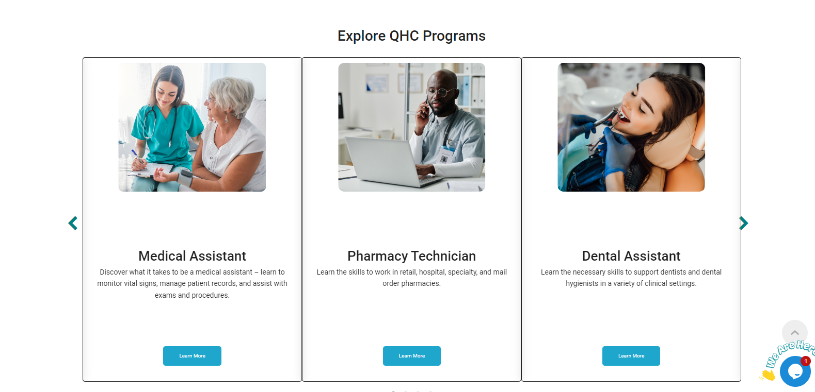**Alignment Issues:** This Arrow button should be Properly well aligned



**Improper Form Positioning on Desktop and Mobile**: The form is not positioned correctly; on the desktop, it is too low, and on mobile, it is at the very top. The form should be lower.

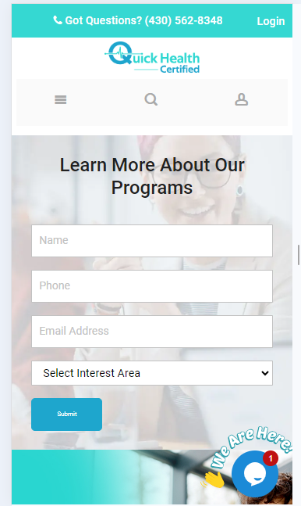

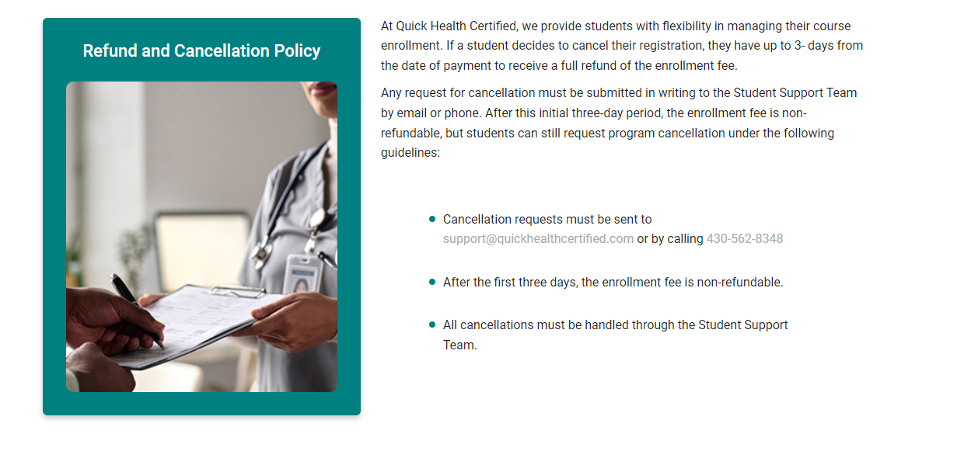

**Text format Issue**: The highlighted text has gray in color which should be black



**WORK WITH US PAGE AUDIT**

**Performance Issues**: Performance on mobile is 64 should be above 90+

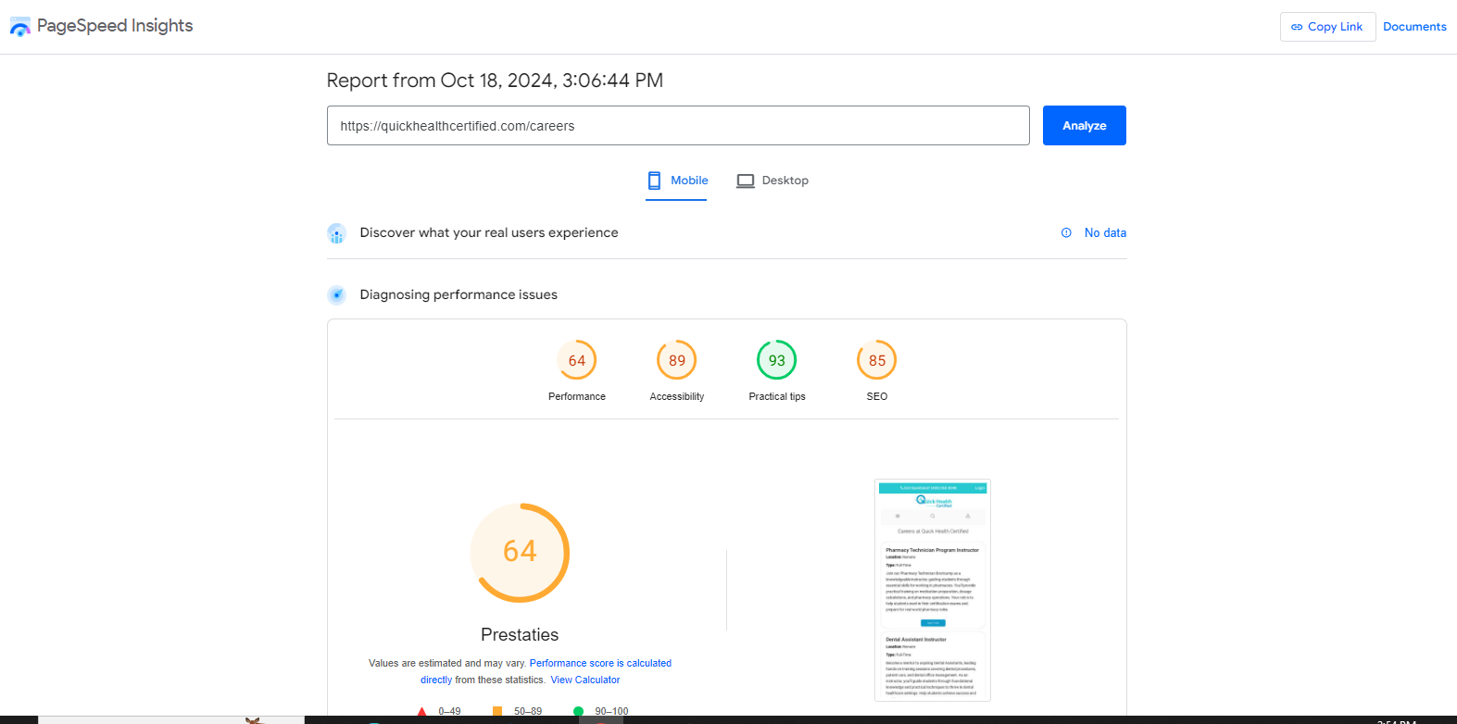

**Mobile Responsive Issues:** The **'Apply Now**' CTA button should be responsive in all job listings on the careers page

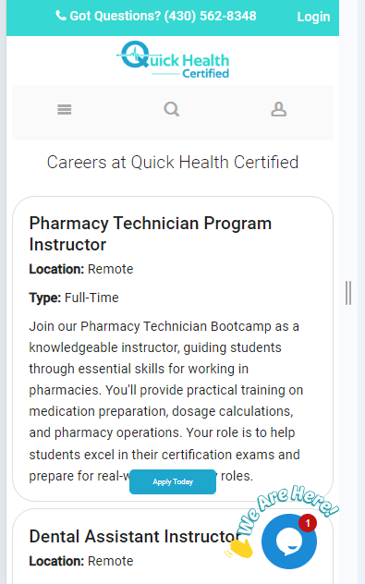

**Recommendation**: Each job listing on the Career page should have a dedicated page that adheres to Google’s guidelines by implementing structured data using the Job Posting schema. This approach can help improve our rankings in SERPs.

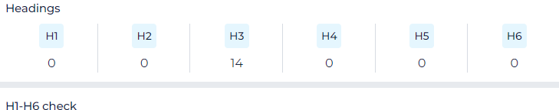**Header Tag:** No h1 tag has been found in About us Page

**Schema Markup**: No Schema data has been implemented

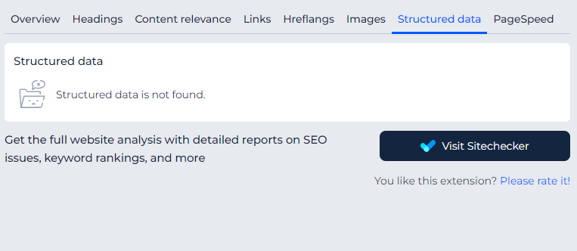

**OUR SPONSORSHIP PAGE AUDIT**

**Performance:** Performance on mobile is 53 should be above 90+

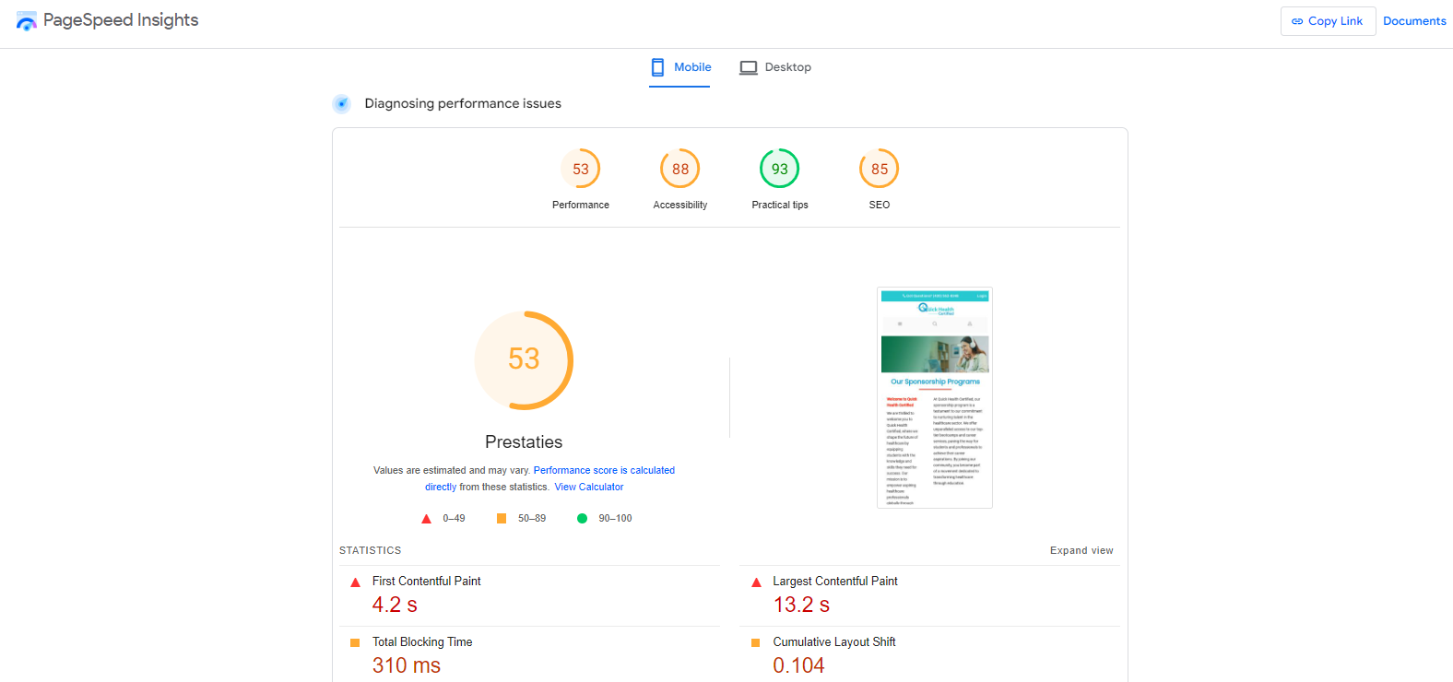

**Performance:** Performance on Desktop is 66 should be above 90+

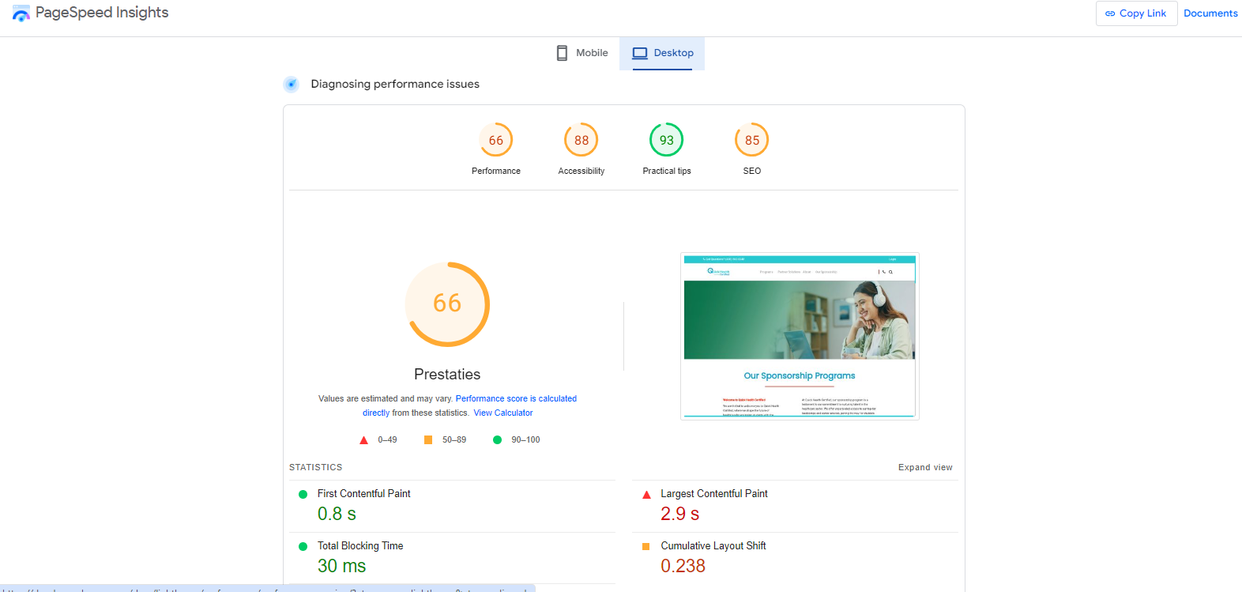

**Mobile Responsive Issues**: The whole page is not mobile responsive

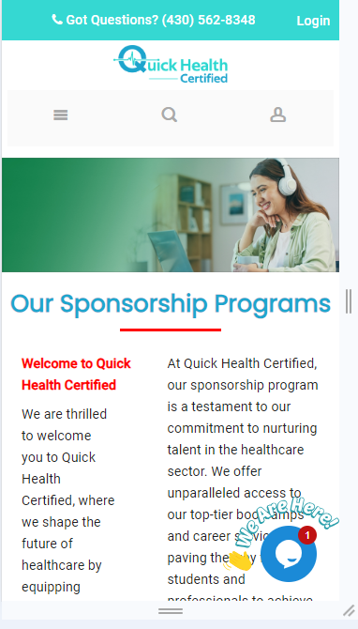

**Text format Issues**: Some Text is blue I color and are bold and some text is bold, the text format should be in same color

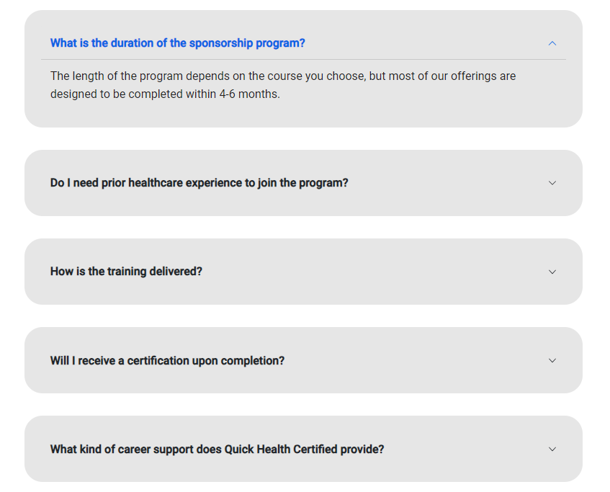

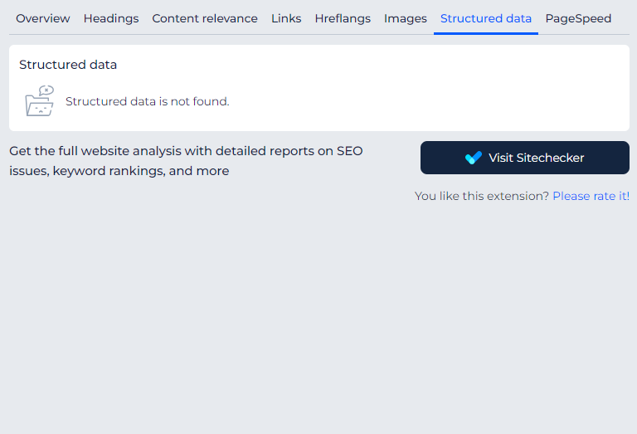**Schema Markup:** The structured data is not found

**Image Alt text**: One Image does not have an alt text

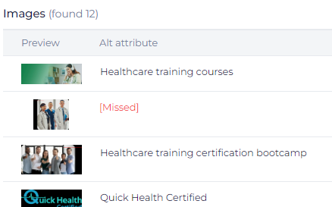

**Recommendations**

* Our program pages should be properly optimized for SEO, including the strategic insertion of relevant commercial keywords, and feature an improved layout. Additionally, the program pages currently lack a footer, which needs to be addressed.
* Furthermore, we should implement a blog page that includes a content funnel to enhance engagement and user experience
* The site should have breadcrumbs
* The site should HTML Sitemaps